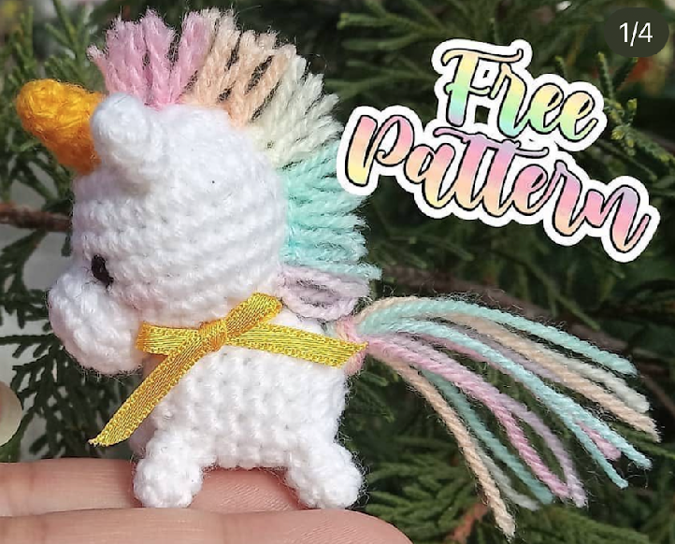**Mini Unicorn Crochet Pattern**

***\*2mm Hook – Safety Eyes\****

**Head;**  
R1: SC6 in MR [6]

R2: Inc x6 [12]

R3: (SC, Inc) x6 [18]

R4: (SC2, Inc) x6 [24]

R5-8: SC around [24]

R9: (SC2, Dec) x6[18]

R10: (SC, Dec) x6 [12]

Fasten off, leave tail for sewing.

**Body;**

R1: SC8 in MR [8]

**Horn;**

R1: SC4 in MR [4]

R2: SC around [4]

R3: (SC, Inc) x2 [6]

R4: (SC2, Inc) x2 [8]

R2: Inc x8 [16]

R3-8: SC around [16]

R9: Dec x8 [8]

Fasten off.

**Legs (Make 4);**  
R1: SC5 in MR [5]

R2-3: SC around [5]

Fasten off, leave tail for sewing.

**Ears (Make 2);**

R1: SC4 in MR [4]

R2: (SC, Inc) x2 [6]  
R3: (SC2, Inc) x2 [8]  
Fasten off, leave tail for sewing.

**Muzzle;**

R1: SC6 in MR [6]  
R2: Inc x6 [12]

R3-4: SC around [12]

Fasten off, leave tail for sewing.